Ideation Phase
Brainstorm & Idea Prioritization Template

Date | 17 February 2026
Team ID | LTVIP2026TMIDS39366
Project Name | Heritage Treasures: An In-Depth Analysis of UNESCO World Heritage Sites (2019)
Maximum Marks | 8 Marks

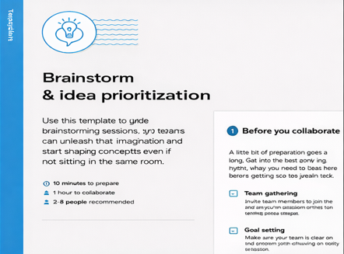
Step-1: Team Gathering, Collaboration and Select the Problem Statements

Step-2: Brainstorm, Idea Listing and Grouping

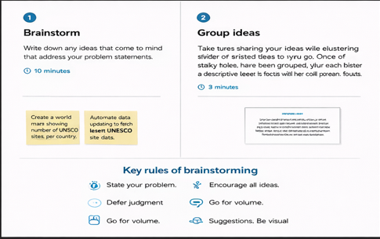
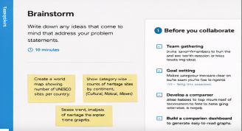
Step-3: Idea Prioritization
